1. Home page - Line space in between content of the block -

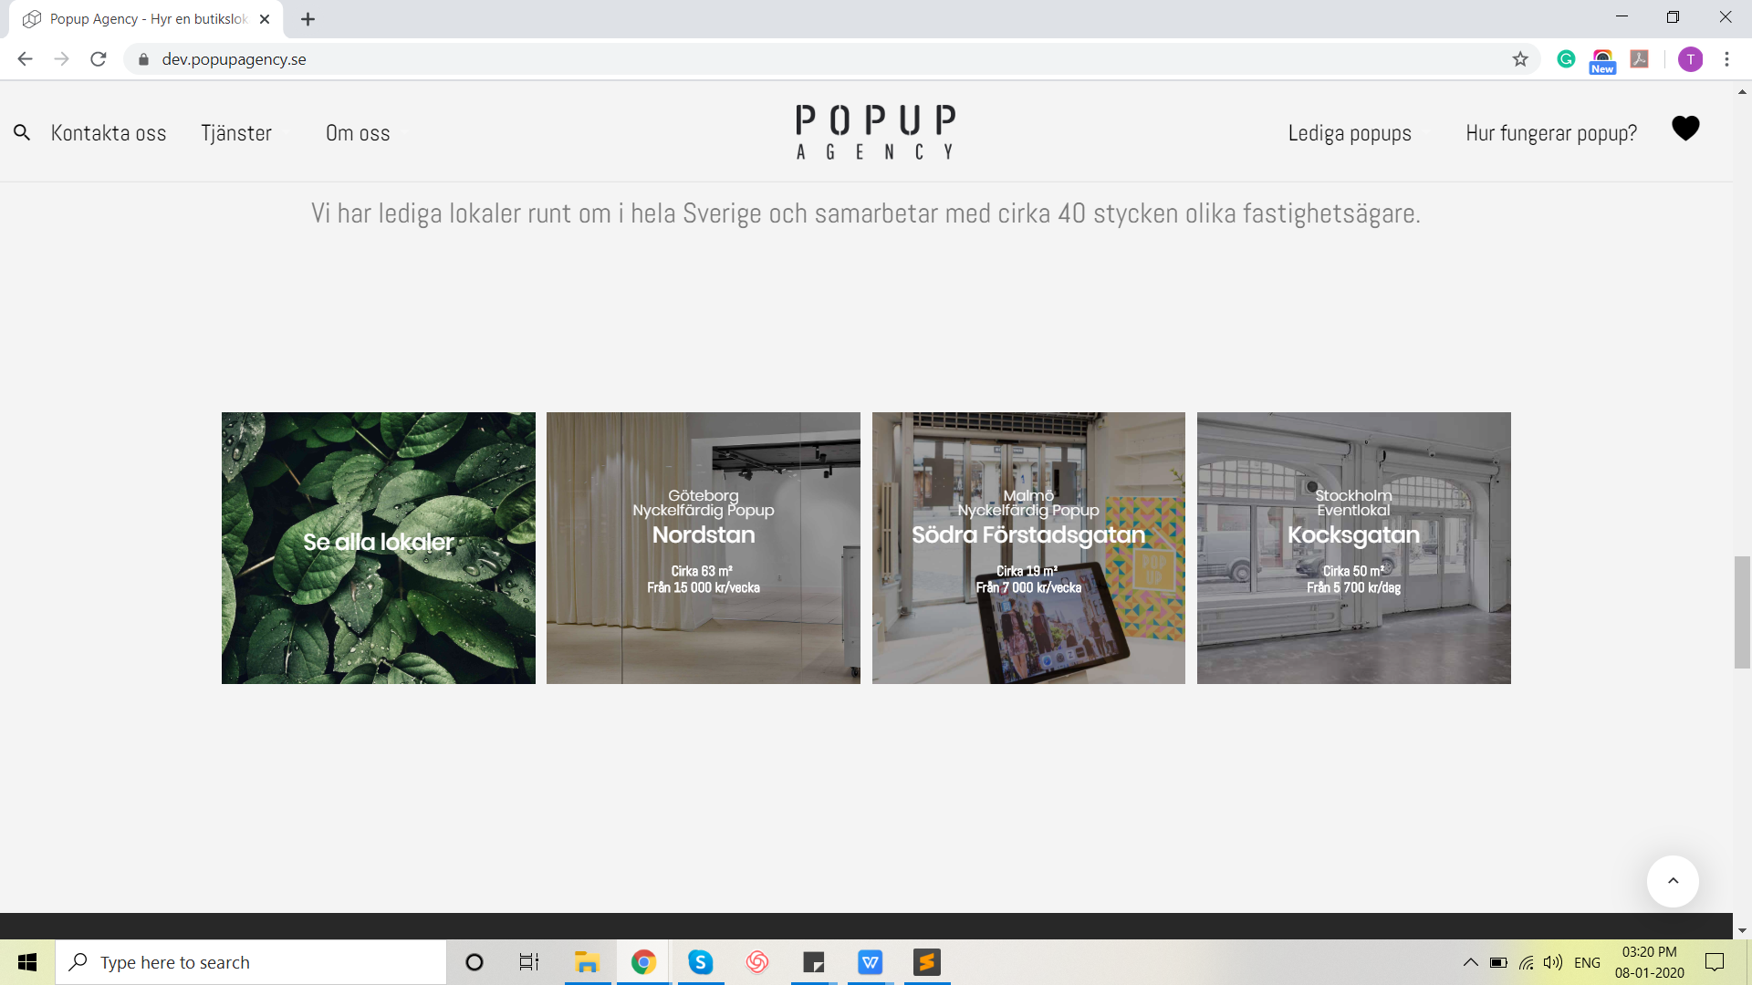

1. Search bar - Font of placeholder is small.
2. Live <https://www.popupagency.se/lediga-lokaler/?type=rent&search_keywords=gotland&sort=senaste> -

Dev - <https://dev.popupagency.se/lediga-lokaler/?search_keywords=gotland&sort=senaste>

1. Language -



Live -



1. Bookmark option is slightly misplaced.
2. Check currency -

Live -

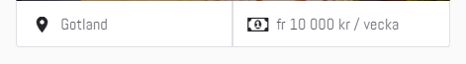

Dev -



1. Filters -

Live -

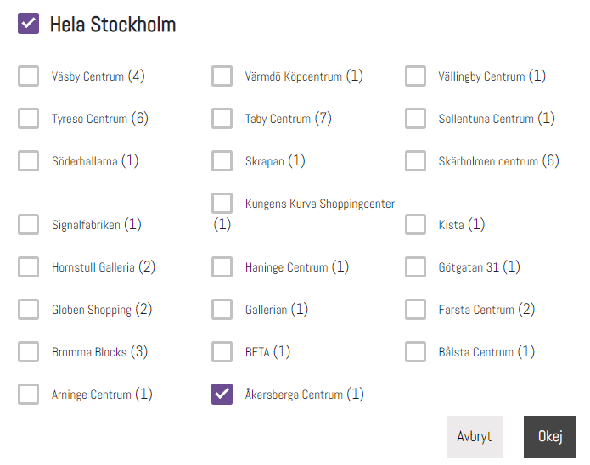

Dev -

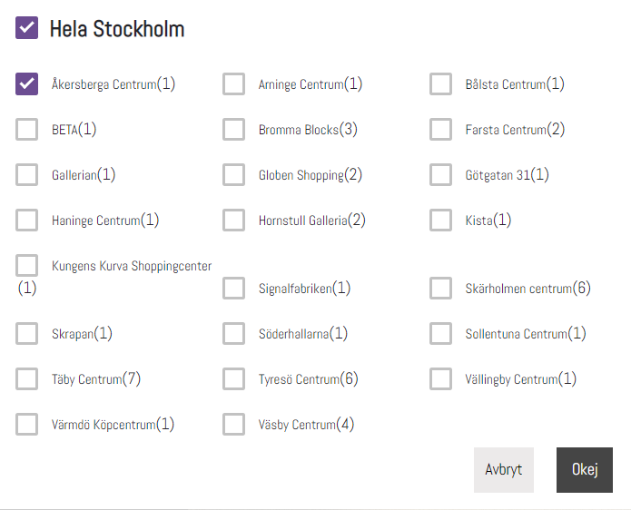

Check box options are not in alphabetical order.

1. Live -

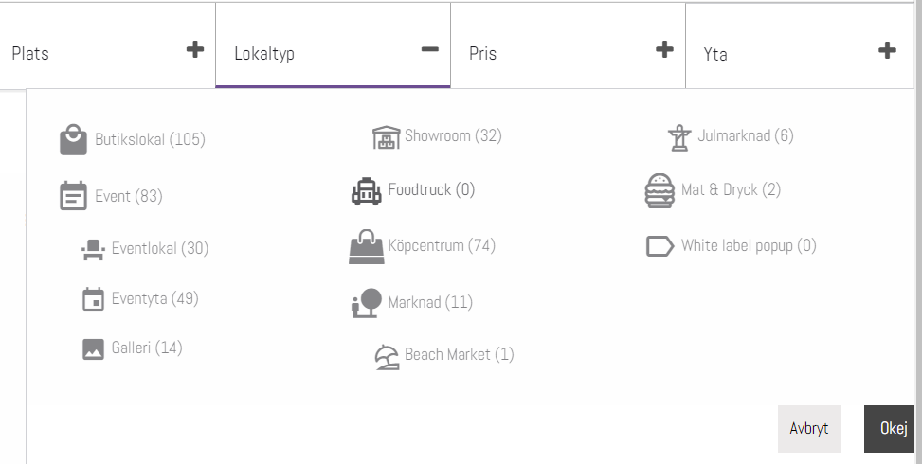

Dev -

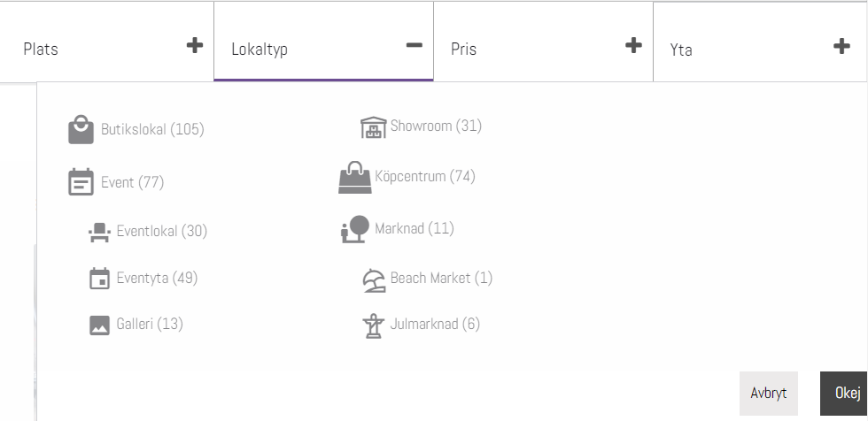

1. Cancel button translation-

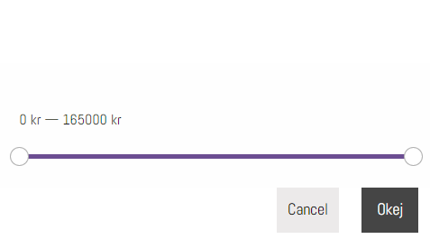

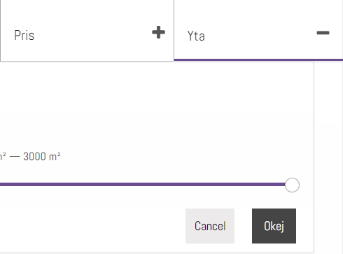

1. <https://dev.popupagency.se/hela-landet/stockholm/akersberga-centrum/>

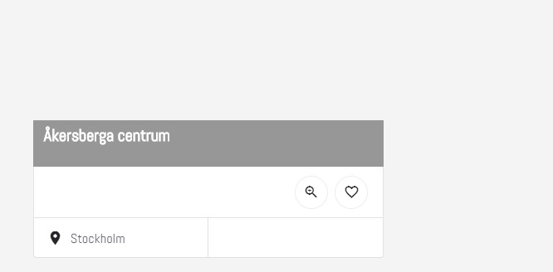

Live -

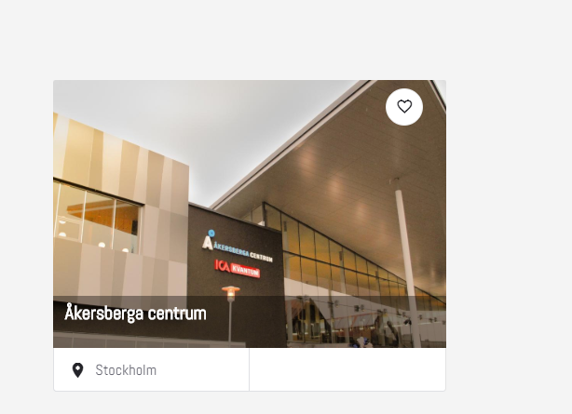

Please check for all similar pages.

Mobile -

1. Search page -

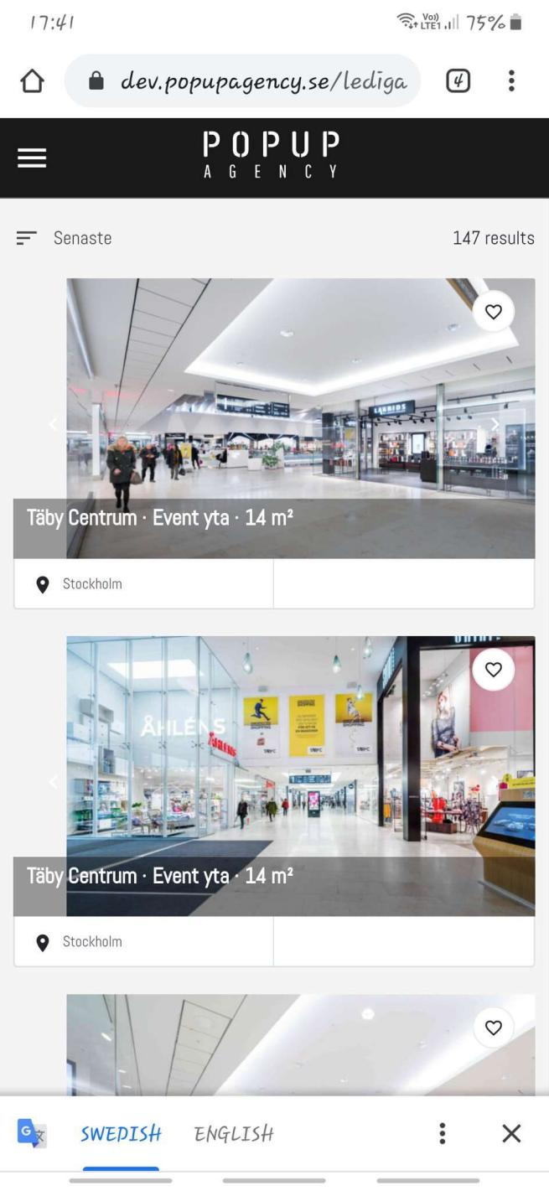

1. Result is differ from live after applying filter.